horizontal line

Grand Traffic Auto

User Manual

**24th October 2019**

**Project Team**

|  |  |
| --- | --- |
| **Name** | **Student Number** |
| Robert Pennefather | 21511164 |
| Daniel Gonzalez | 22024722 |
| Martin Porebski | 21498791 |
| Jacqueline Soon | 21719676 |

## 

**1.0 Introduction** **2**

1.1 About the Grand Traffic Auto application 2

**2.0 Users** **2**

**3.0 Admin** **3**

3.1 Configuring the Game 3

3.2 Collecting the Data 4

**4.0 Player** **6**

4.1 Playing the Game 6

## 1.0 Introduction

Due to the increasing complexity of transportation people now, more than ever, have more options to choose from during their everyday commutes. Alternatives to driving include sophisticated public transport, autonomous vehicles and rideshare services such as Uber. With the advancement of the GPS and navigation technology, software applications are becoming faster and more efficient at presenting us with the quickest and cheapest routes to our destinations. Furthermore they offer online updates about the state and level of congestion of our route.

Researchers at UWA are looking to conduct experiments that will measure how people respond and react in various different transport-based events. Grand Traffic Auto was created to simulate a variety of scenarios for people to make choices regarding their transportation. The game is hosted on a UWA server, gathers information about the subjects and stores it in an online database for easy access. This gives researchers a framework to conduct transport economics experiments in a controlled environment, while giving participants a game to enjoy.

### 1.1 About the Grand Traffic Auto application

Grand Traffic Auto was created to improve the classic approach of polling people on transportation using paper based surveys. The game is immersive and it provides a participant with a context to the queries of the research while it also safely stores the results on the cloud. It simulates a realistic transportation scenario in which the decision-based data is collected more accurately because the participants are answering questions in response to real-life simulated events. Grand Traffic Auto gathers information regarding specific choices a passenger makes in complex transportation environments. Ideally this project will provide a digitised and improved way to run surveys, in replacement for paper based ones.

## 2.0 Users

There are two types of users in the Grand Traffic Auto application. The first is the administrator/researcher (Admin) who creates the different types of experiments they wish to run and collect data about. The Player is the second type of a user, who plays the game and gives responses which are collected for the researcher’s experiments.

## 3.0 Admin

The admin panel is accessible from the website currently located under [www.130.95.176.166/webapp](http://130.95.176.166/webapp/config) by specifying the appropriate credentials. This server is hosted on the UWA network and can only be accessed while on the network. The link contains the configuration tab, which is used to setup a game session, as well as the option to start the game, which is used for the Player user.

### 

### 3.1 Configuring the Game

After navigating to the website, select the “*Configuration*” tab from the menu in the top right corner. This will display a form with the following fields:

* Starting Cash - initial money allocated to the player at the start of the experiment.
* Time Scale - ratio used to modify the base time of the session.
* Money Scale - ratio used to modify the base money operations in the session.
* Number of Trials - total trips in the session.
* Request Times - times at which a phone notification will appear, modified by “*Time Scale*”.
* Array of base travel time - base time of a trip in a session, modified by “*Time Scale*”.
* Array of diversion times - time taken for each trail, modified by “*Time Scale*”.
* Array of base cost - base cost of a trip in a session.
* Array of savings - cost saving of every decision.
* Include driver - enable a driver (taxi or rideshare). Otherwise, simulate an autonomous vehicle.
* Include friend - enable a second passenger as your companion.
* Multiple passengers - enable simulation of more passengers to be picked up at a single stop.

After submitting the form, a configuration string will appear on the screen. Copy this code and distribute it to the players to use as the “*Game Session ID*”. This string is an encoded message that will configure the Unity game as specified.

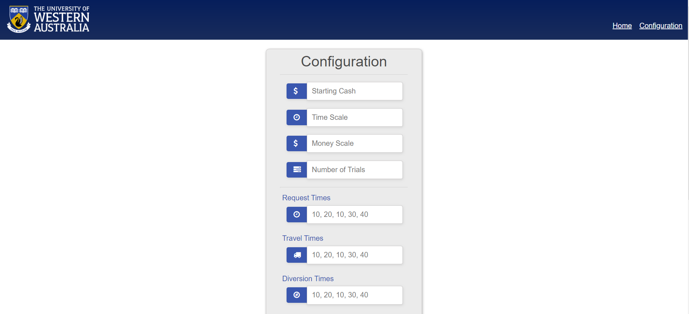

### 3.2 Collecting the Data

Once a player has completed the game their experimental data is sent to the cloud-based database. This is a MongoDB server hosted on the Atlas platform under <https://www.mongodb.com/cloud/atlas>. To access this the administrator user must have an account added to the Atlas project. There is more information about how to do this in the Maintenance Manual sections 3.1 and 3.2.

All information sent from the game is stored on the MongoDB Atlas dashboard under Atlas → Clusters. This will show the available clusters and their options. Clicking on the “*Collections*” button for GrandTraffic will show the admin the uploaded Unity data. This will also allow you to query the information for a specific session configuration or player ID.

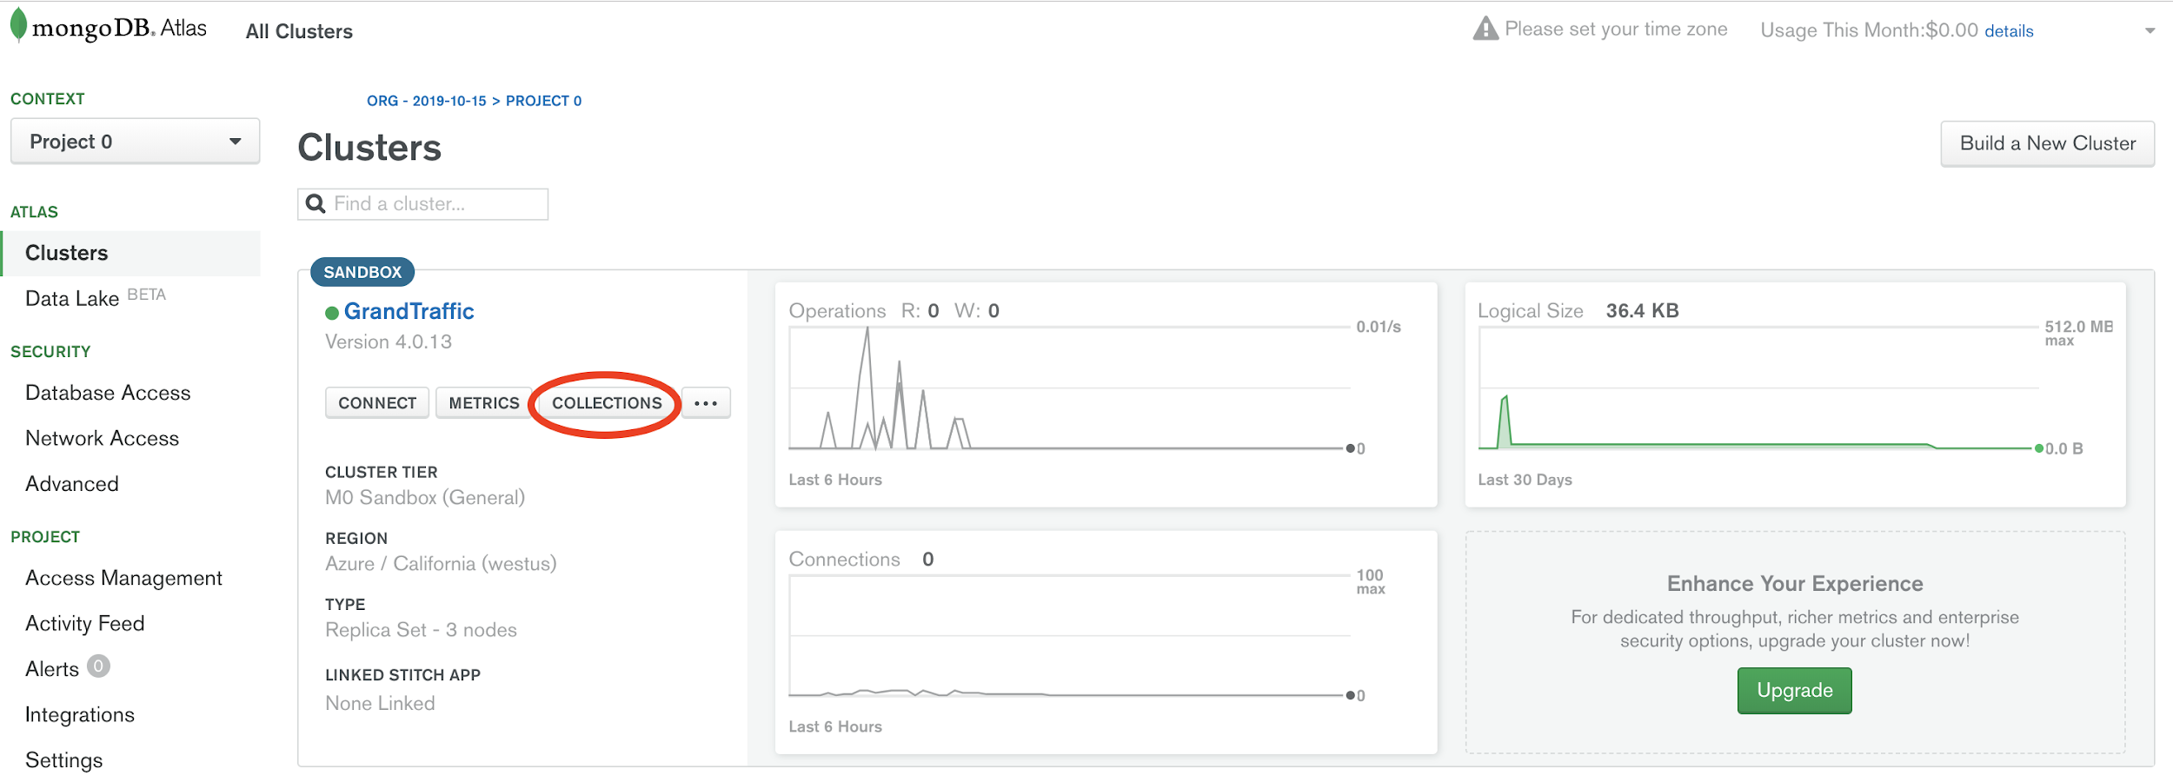

The database stores the following information:

* Game ID - a string describing the configuration options of the session. This is the same string the player’s will enter at the beginning of their game session, and the string produced by the admin in the previous step.
* Player ID - unique identifier of the player in the session, used to cross-reference with the outcomes of the survey.
* Diversion Choices - a boolean array of the decision to pick up a passenger made by the player each round. Selecting to pick up another passenger results in a “true” entry while not picking up a player gives “*false*”. If no decision is made by the player once the round ends, a “*false*” decision is saved into this array.
* Response Time - an array of floats measuring the total time taken for the player to make the decision to pick up another passenger. The time is measured from the point of the notification bell from the phone, and a value of -1 is saved to the array if no decision was made by the end of the round.
* Total Money - final amount of money the player ends the game with, after the cost of all trips has been deducted.

An example of a single player’s entry into the database can be found in the figure below. This screenshot also displays the “*filter*” option provided by Atlas (circled in red). This allows an admin to query the data based on specific fields. For example the query: *{“GameID”: “testGameID”}*, would display the data for all experiments by players with the same configuration of experiment. Allowing the results to be filtered can lead to more efficient analysis of the data by the admin. Additional information about querying can be read in the Atlas documentation and support, this is found under the Help section on the dashboard.

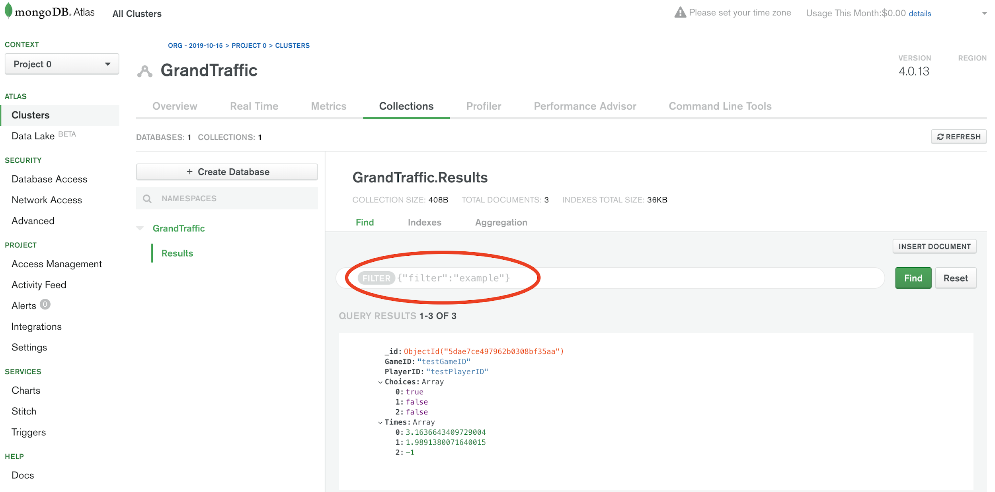

## 4.0 Player

Initially in the experiment the player will be given a survey by a third party source to gather some preliminary information about their gender, age etc. After the survey is complete, the player can access the game from [www.130.95.176.166/webapp](http://130.95.176.166/webapp/config). Again the server can only be accessed while on the UWA network.

### 4.1 Playing the Game

After the first survey is complete and the website is loaded, the player can navigate to the game by clicking the “*Play!*” button on the main screen. This will take the player to the traffic game which will begin to load on the client’s device.

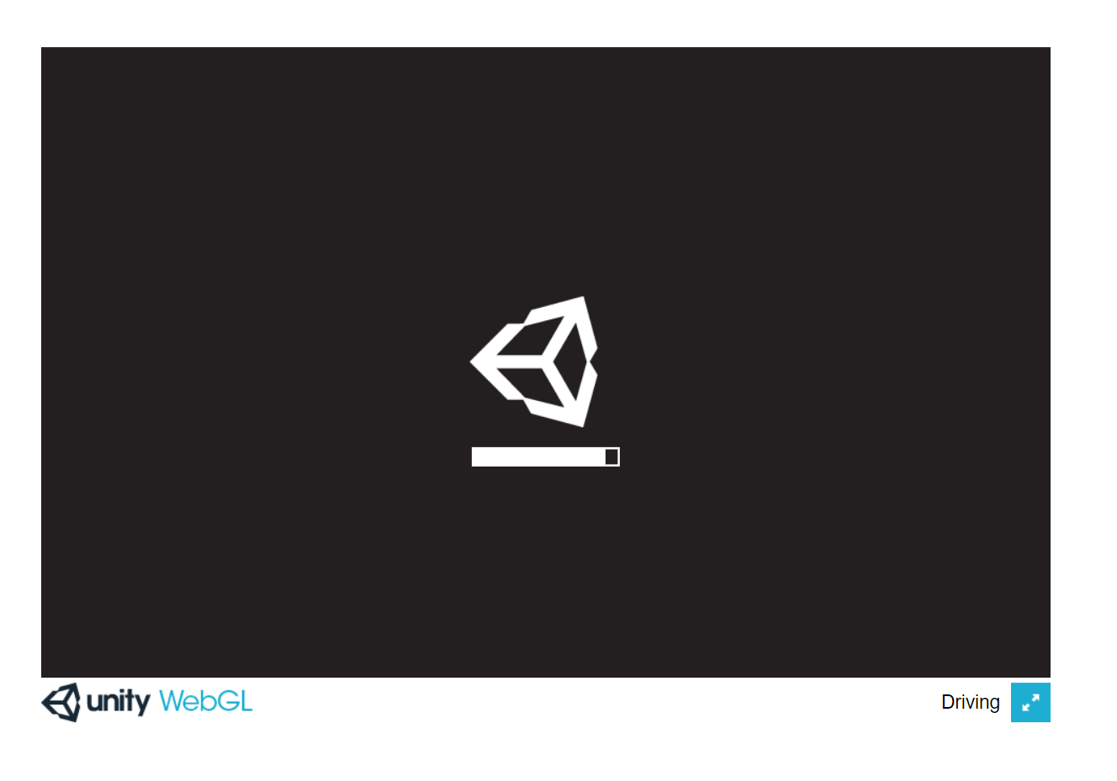

Once the game loads the first screen shown is a menu screen with two text fields. The game ID will be supplied by the admin, this string configures the rest of the game and determines information about the various rounds. The player ID will also be supplied by the admin, this is used to cross reference the data collected in the survey sections of the experiment. It is out of scope how the player ID is created or handled during the experiment, but the field here must be inserted by the player to continue. Both these text fields must be filled in before the player can continue, once completed the player can click the “*Play*” button to move to the next screen of the game. If any of the fields were incorrectly filled in an error message will appear asking the player to correct the error.

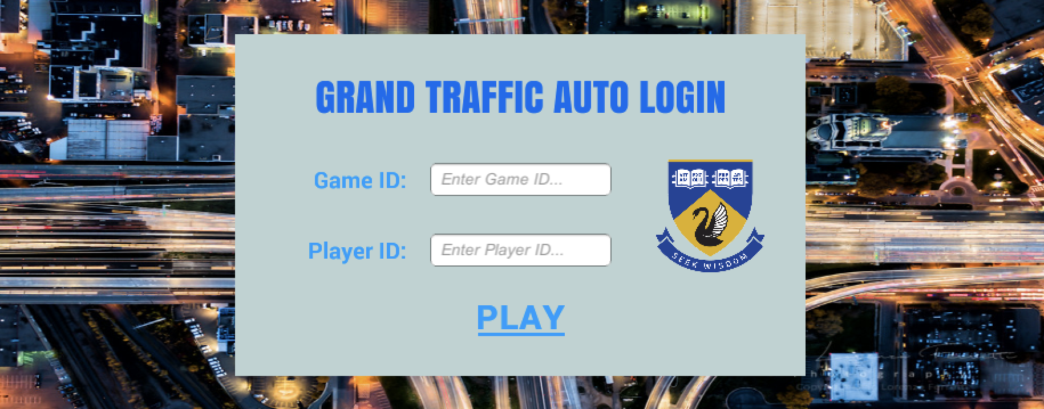

Next the player will be taken to the main game screen. The player takes the role of a passenger in a car. The camera is a first person view point, with various UI elements in the HUD. A minimap is shown in the bottom left hand corner, information about the ETA and cost of the trip are in the top right hand corner as well as the total money the player currently has.

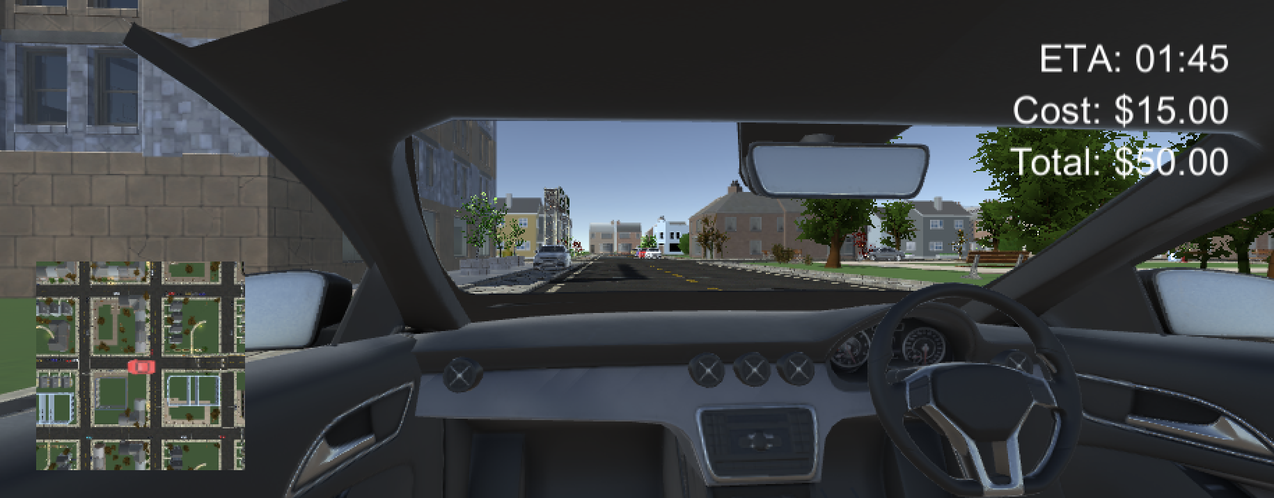

The player can turn the camera horizontally with a fixed rotation by moving their mouse. The car will begin to move and the driver/AV will take the player on a trip to their destination. After a predetermined amount of time a phone will appear with a notification for the player. The player is asked if they would like to pick up another passenger on their trip, which will decrease the cost of their trip, but increase the time taken to get to their destination. A decision can be selected by clicking on either the “*Yes*” or “*No*” buttons on the phone (or ignored for the remainder of the trip). The ETA and cost will be updated once a decision is made.

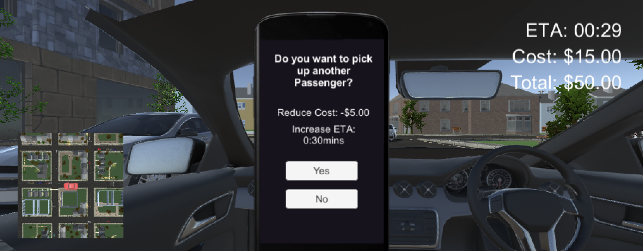

Once the ETA reaches zero the round will end, as the player has been delivered to their destination. The cost of the trip is then deducted from the player’s total money. Multiple rounds will occur each with different trips, costs and decisions (determined by the admin). Once all rounds have been completed the game will show the end screen to the player. This screen displays the total amount of in game money the player ends with, which is used to determine how much the player is paid for performing the experiment. The player is also prompted to complete another survey to finish the experiment. Again this final survey uses a third party system, and is out of scope of this project.

